Database Systems

Lab Manual (Lab 8)



Session: Fall 2024

LAB INSTRUCTOR: AYESHA MAJID ALI

## **Lab Exercises**

### Exercise 1: Simple Subquery in the WHERE Clause

* **Task**: Find all employees who are earning more than the highest salary in the "Marketing" department.

SELECT Name, Salary

FROM Employees

WHERE Salary > (SELECT MAX(Salary)

FROM Employees

WHERE Department = 'Marketing');

### Exercise 2: Subquery in the SELECT Clause

* **Task**: List the name and salary of all employees along with the department name they belong to.

SELECT Name, Salary,

(SELECT Department_Name

FROM Departments

WHERE Departments.Department_ID = Employees.Department_ID) AS Department

FROM Employees;

### Exercise 3: Subquery in the FROM Clause

* **Task**: Find the average salary per department, but only for those departments with more than 5 employees.

SELECT Department_Name, AVG(Salary)

FROM (SELECT Department_ID, Salary

FROM Employees

GROUP BY Department_ID

HAVING COUNT(Employee_ID) > 5) AS SubQuery

JOIN Departments ON SubQuery.Department_ID = Departments.Department_ID

GROUP BY Department_Name;

### Exercise 4: Correlated Subquery

* **Task**: List the names of employees who earn more than the average salary of their respective departments.

SELECT Name, Salary

FROM Employees e

WHERE Salary > (SELECT AVG(Salary)

FROM Employees

WHERE Department_ID = e.Department_ID);

### Exercise 5: Nested Queries with Multiple Conditions

* **Task**: Find the names of employees who are working on the "AI Research" project and earn more than the average salary.

SELECT Name

FROM Employees

WHERE Employee_ID IN (SELECT Employee_ID

FROM Projects

WHERE Project_Name = 'AI Research')

AND Salary > (SELECT AVG(Salary) FROM Employees);

LAB TASKS:

Sample Table:

1. **Employee Table:**

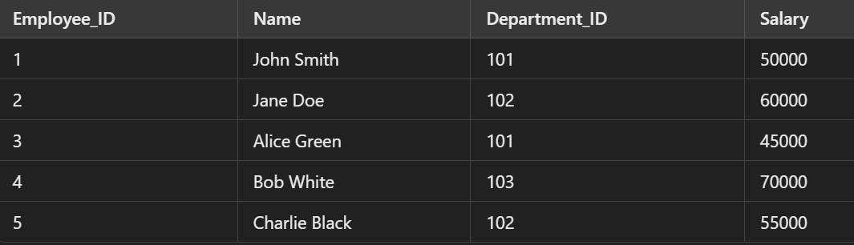

1. **Departments Table**

1. **Projects Table**

1. Retrieve employees who earn more than the average salary across all employees.
2. List the name of each employee along with their department name.
3. Find the total salary expense for each department.
4. List employees who earn more than the average salary in their respective departments.
5. List employees who are working on the "AI Research" project and earn more than the average salary.
6. Find departments that have more than 2 employees.
7. Find employees who are not working on any project.
8. Find employees who earn more than all employees in the "Sales" department.